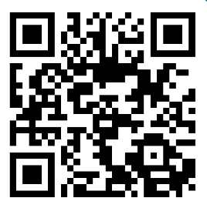
Follow the QR code to report your sightings
Have you seen these species?
Hedgehog
Bullfinch
Common Lizard
Slow worm
Common Frog
Common Toad
Stag Beetle
Smooth Newt
Grass Snake
Brown Hairstreak
Purple Emperor
White Admiral

